Principal Component Analysis and Quality Classification using PyCaret
Name []: ID []: INSE 6220 — Advanced Statistical Approaches to Quality: Date []

Abstract-The growing sophistication of the production systems and service environment has enhanced the necessity of strong statistical solutions in quality engineering. The purpose of the current study is to examine how Principal Component Analysis (PCA) with supervised machine learning can be used to improve the quality classification and decision-making performance. Wine data is used in its quality proxy, which is a real-life multi-attributes system where chemical composition changes affect the product classification. PCA is used in a methodological approach to reduce the dimensionality and maintain the important variance followed by classification with PyCaret, a low-code machine learning platform. Logistic Regression, K-Nearest Neighbors, and Quadratic Discriminant Analysis are some of the models that are trained, tuned, and evaluated. The findings show that PCA provides an effective way of condensing the data without much information being lost and KNN model predicts the best.
2. Introduction
2.1 Quality Engineering and Statistical Analysis Development
Over the last hundred years, quality engineering has been transformed to some extent as the reactive and inspection-based practices have evolved into data-driven and proactive quality management systems. Quality control was mainly concerned with inspection of the end products, and this was carried out at an early stage where faulty products were detected and eliminated. This method was however ineffective and expensive and gave way to statistical quality control (SQC) that was developed in the first half of the 20th century under the guidance of leaders like Walter A. Shewhart [1]. The process capability indices, control charts and sampling plans became basic tools in the monitoring of manufacturing consistency.
With the increasing complexity and automation of industrial systems, univariate statistical techniques could no longer be used to manage the interdependencies between the various variables related to quality. This requirement led to the development of multivariate statistical methods, and sophisticated methods like multivariate control charts, factor analysis and Principal Component Analysis (PCA) were developed [2]. These approaches allowed the engineers to capture more general relationships in complex systems giving them a more holistic picture of quality dynamism. Currently, quality engineering unites both statistical analytics and machine learning and artificial intelligence to identify abnormalities, anticipate failures, and optimize the production system in advance.
2.2 Data-Driven Decision-Making role in Quality Improvement
Evidence-based decision making has become the hallmark of quality improvement plans in the modern day. Organizations are turning to be more dependent on the massive amount of process data to steer the continuous improvement effort and promote consistency in product and service delivery. Instead of descriptive statistics and other intuitive or empirical inferences, data-driven approaches convert raw data into practical application insights via formal analytical procedures.
In quality engineering, predictive maintenance, root cause analysis and real-time quality monitoring can be performed with the help of data-driven decision-making [3]. Through trend analysis, organizations will be able to discover concealed trends, detect deviations at an early stage and take corrective actions before the defects go out of control. This does not only increase the efficiency of the operations but also lowers waste levels, lowers the production costs and increases customer satisfaction. The introduction of Industry 4.0 has pushed the need to incorporate in the quality systems advanced analytics that would ensure the continuation of competitive advantage.
2.3 Principal Component Analysis Overview
The Principal Component Analysis (PCA) is a central statistical technique employed to reduce the original high dimensional data to a lower dimensional representation whilst maintaining most of the variance of the original dataset [4]. The mathematical intuition of PCA is the following: the principal components are orthogonal axes that are linear combinations of the original variables. These elements are calculated by using eigenvalue decomposition of the covariance matrix or the singular value decomposition of the standardized data matrix.
The significance of PCA is that it removes multicollinearity, redundancy, and maximizes the meaning. PACA reduces the complexity of the system and enables the visualization of the data by mapping the data on fewer components, especially in two- or three-dimensional space [4]. This renders PCA very useful in quality engineering whereby very many correlated measurements may be at play. It is also more efficient in computations and model stability, particularly when found in combination with machine learning algorithms.
2.4 Machine Learning in Quality Control
Machine learning has completely revolutionized the concept of quality control since it has brought about intelligent systems that learn and make decisions on their own. One of the most influential paradigms in the field of ML is supervised learning where models are trained on labeled data to provide predictions or categorization of novel observations. Supervised learning models have been used in quality assessment to categorize products into acceptable and defective, forecast degradation patterns, as well as discover unusual process behavior [5].
In this case, classification is very important in dictating quality outcomes. The Logistic Regression, the K-Nearest Neighbors, and the Quadratic Discriminant Analysis among others are algorithms that allow proper grouping of products according to their profiles of attributes. These algorithms can be used in conjunction with PCA to work on a more refined feature space, which enhances interpretability and performance and reduces the cost of computation.
2.5 Purpose and Scope of the Study
The main goal of the research is to prove the efficiency of the combination of the PCA method with machine learning algorithms being used to classify the quality. PCA plus supervised learning works well since it provides a compromise between reducing dimensionality and the prediction rate. PCA eliminates irrelevant features or redundant features so that machine learning models concentrate on the most informative elements.
The use of PCA on the Wine data as a proxy of quality analysis, classification with PyCaret, and performance of the model and interpretation of its results with SHAP are the scope of this research. Industrial quality monitoring relevance the applicability of this methodology to manufacturing, healthcare, logistics, and service quality systems where multivariable data is common is associated with the applicability of this methodology.
2.6 Structure of the Report
The present report has a number of structured parts. The introduction is succeeded by the dataset and problem statement that contains the main characteristics and the research purposes. The processing of PCA and machine learning has been outlined in methodology section. This is then discussed by experimental results and model interpretability, critical analysis, conclusion and recommendations to researchers in the future. To facilitate transparency and reproducibility, supplementary data, and code references are presented in the appendices.
3. Dataset and Problem Definition
3.1 Wine Dataset Description
The data used in this research is the Wine data which is a recognized multivariate data initially acquired through chemical analysis of the wines produced in the same area of Italy but through three different cultivars. It has been popular in statistical and machine learning studies because of its balanced format, rich attribute formation, and the appropriateness to classification undertakings. The dataset can be funneled publicly using the scikit-learn library, which is transparent and reproducible to experimental analysis [6].
It has a dataset of 178 observations (samples) and 13 continuous attributes that are the chemical properties of wine. These characteristics are Alcohol, Malic Acid, Ash, Alcalinity of Ash, Magnesium, Total Phenols, Flavonoids, Nonflavonoid Phenols, Proanthocyanins, Color Intensity, Hue, OD280/OD315 of Diluted Wines, and Proline [6]. The observation is categorized by one of three different values of the classes (0, 1 or 2) that relate to the particular cultivar of the wine.
In terms of domain, these attributes represent differences in chemical composition which directly impact on taste, aroma and overall quality of wine. In this way, the dataset is a plausible proxy of quality assessment with each chemical feature combination signifying production and fermentation processes and product stability. The classification problem resembles the industrial quality distinction, which is why this data is suitable in the context of quality engineering and analytics demonstrations.
3.2 Relevance to Quality Engineering
In quality engineering, it is essential to have an understanding of how input variables influence the ultimate product quality. Wine dataset reflects the same relationship as it correlates chemical composition to categorical quality results. Every attribute is a quantifiable input factor that culminates into the observable features of the end product, which are signified by class labels [7].
This direct correlation between composition and classification corresponds to quality control situations in the real world where a deviation in the composition of the materials used, the temperature of the processing process, or deviation in the ratios of the ingredients constituting the product can result in a change in the product quality. This paper has shown through analysis of the Wine data that high level statistical methods can be used to reveal the statistical relationships between the process variables and quality results [5]. The capability to differentiate wine classes in terms of chemical properties is a simulation of the manufacturing or services industry which is in need of acceptable products or defective products.
Besides, the dataset summarizes common issues in quality monitoring such as correlated variables, shared class boundaries, and noise that is inherent to measurement systems. This study, through the use of PCA and machine learning models, is effectively used to show how quality engineers can make use of complexity without losing interpretability and predictive accuracy.
3.3 Data Characteristics
The Wine data has various statistical features which render it difficult and perfect to undertake multivariate analysis. To begin with, the trends of the features are quite different. There are those variables that exhibit near-normal distributions like Alcohol and Magnesium while other variables like Proline and Color Intensity exhibit skewed distributions [6]. This variability in distribution explains the significance of standardization and normalization in the preprocessing phase.
One of the main features of the data that is critical is that there is multicollinearity. Attributes like Flavonoids and Total Phenols are highly correlated, because they are similar compounds chemically. The existence of high correlation between the predictors may adversely affect the stability of the machine learning models and mislead variable importance. This strengthens the applicability of the Principal Component Analysis, which abilities correlated variables into own components, and thus overcomes the redundancy problem.
From the preliminary exploratory observations, it is evident that the clustering tendencies are visible when plotted using the two-dimensional projections. Some classes are distinctly separated, whereas others have overlapping, which suggests that there are no linear decision boundaries. These attributes warrant the adoption of PCA as a dimensionality reduction algorithm and encourage the next step of adopting supervised classification methods [6]. The complexity of the dataset is a strength that contributes to making it an analytical standard of quality-oriented machine learning structures.
3.4 Research Questions
The research questions that lead to the study are the following:
- What is the best way by which Principal Component Analysis can maintain the informational integrity of the original dataset and be able to reduce the dimensions?
- What machine learning model (Logistic Regression, K-Nearest Neighbors or Quadratic Discriminant Analysis) would give the most valid and realistic classification of wine quality?
- Which are the interpretable features i8n the reduced features produced by PCA and what are their use in making a decision by the model?
These are the questions that define the analytical base of the study and define the assessment of both of statistical and machine learning techniques. The obtained responses give an idea of the feasibility of the application of combined PCA-ML methodologies in quality optimization models.
4. Methodology
4.1 Data Preprocessing
Handling the Dataset
The first phase with the methodology was the importation of the Wine dataset into the structured data frame to be processed and analyzed. The data was checked in terms of completeness, consistency, and integrity. As the Wine dataset does not have any missing values, there was no need to use any imputation strategies. However, data type checking made all the attributes numeric, which allowed the computation of PCA to be accurate based on mathematical transformation.
Standardization and Normalization
The StandardScaler technique was used to standardize each feature making the mean to be zero and the standard deviation equal to one. The reason behind this step is that the variables in the dataset are on dissimilar scales e.g. the Alcohol content in a percentage versus Proline in absolute concentration values.
Normalization makes sure that the results of PCA are not dominated by attributes of large magnitude [2]. Balancing the scales of all variables results in an equal contribution of each feature to the covariance matrix contributing to an unbiased principal component structure.
Why PCA needs scaling
PCA is vulnerable to the input feature variance. Absence of scaling would result in features of higher numeric values to exert a disproportionate effect on the direction of the principal components [8]. It would lead to false representations that are a measure of magnitude, and not substantial deviation. Consequently, efficient components extraction and model training require standardization.
4.2 Principal Component Analysis
4.2.1 Mathematical Formulation
PCA works by converting the original data into a new coordinate system that is based on the orthogonal axes referred to as the principal components. This change is based on the covariance table of the standardized data. A covariance matrix is used to describe the strength of linear relationship between all the variables.
$$S={AΛA}^{T}$$
where 𝐴 is the matrix of eigenvectors and Λ the diagonal matrix of eigenvalues. The transformed dataset is obtained by
$$Z=X_{scaled}​A$$
This covariance matrix is also used to compute eigenvalues and eigen vectors. Every eigenvector is the direction of a principal component whereas the associated eigenvalue is the size of the variance explained [9]. The main elements are ordered by their eigenvalues in descending order, so that the first one’s elements capture most of the data variance.
4.2.2 Computation Process
The PCA calculating procedure is structured in the following manner:
- Standardize the dataset.
- Calculate the covariance matrix.
- Carry out eigen decomposition.
- Arrange eigenvalues in the descending order.
- Select top r eigenvectors.
- Estimate the data onto the new component space.
The process is used to reduce the high dimensional data into a lower dimensional representation and retains the most important content of information [4].
4.2.3 Scree Plot Analysis
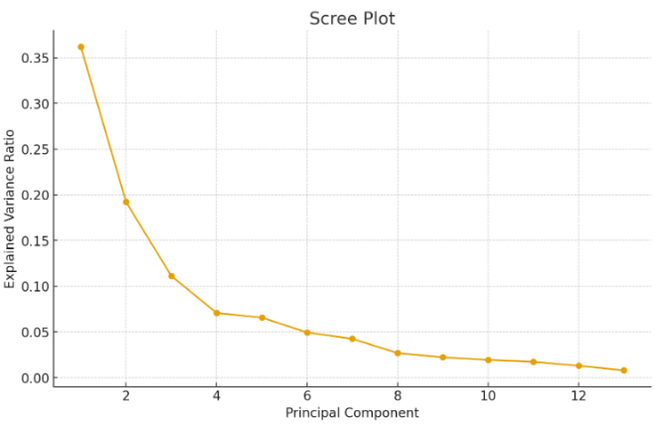
Figure 1: Scree Plot
The scree plot fills the data on the relationship between the principal components and the ratios of explained variance. The point of the elbow is where adding extra components leads to the reduction of explanatory power. The scree plot in this research shows that the four initial components are over 90 compared to the total variance which justifies dimensionality reduction.
4.2.4 Selection of Principal Components
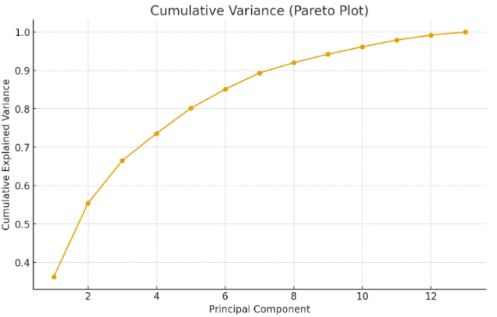
Figure 2: Cumulative Variance / Pareto Plot
The criteria involved in choosing the number of components r is dependent on the cumulative explained variance threshold. The 90 percent cut off point would make sure that in the dimensional reduction, most of the information is retained in the dataset and the model is simplified. This tradeoff leads to the high efficiency to compute and the visualization clarity without compromising predictive ability [1].
4.2.5 Biplot and Feature Contribution
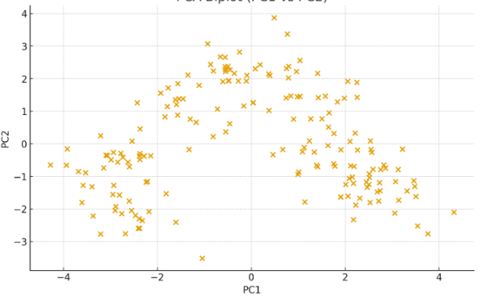
Figure 3: PCA biplot
The biplot represents the projected points as well as contribution of the original variables to the new components. Arrows indicate the eigenvectors, which indicate the contribution of each of the original features to the principal components. Characteristics including Flavanoids and Proline have a great directional effect meaning that they are significant in explaining the variation between wine classes.
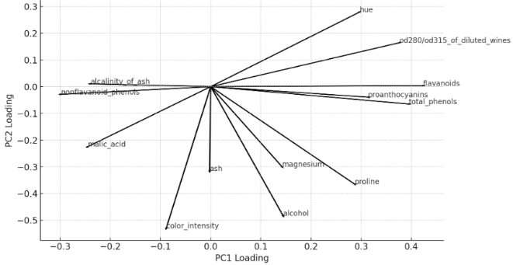
Figure 4: PCA loading (coefficients)
4.3 Machine Learning Modeling with PyCaret
4.3.1 Introduction of PyCaret Framework
PyCaret is a machine learning library that is open-source and low-code and makes it easier to develop, evaluate, and deploy models [10]. It automates preprocessing of data, model comparison, hyperparameter tuning, and performance reporting, which makes it an ideal tool to have a quick experiment and provide transparency in benchmarking the model in quality analytics.
4.3.2 Model Selection Strategy
The models that were used in this study are three classification models such as Logistic Regression (LR), K-Nearest Neighbors (KNN) and Quadratic Discriminant Analysis (QDA) [11]. Logistic Regression gives a linear base model, KNN would give nonlinear relationship, and QDA would give more intricate decision boundaries, through modeling class-specific covariance matrices.
4.3.3 Hyperparameter Tuning
K-fold cross-validation was employed to perform hyperparameter optimization, so that there are models that are tested on the various subsets of the data. This minimized overfitting and enhanced generalization of the models. The tune model in PyCaret automatically modified the values of parameters (varying with tune) like the number of neighbors in KNN and regularization coefficients in Logistic Regression [11].
4.3.4 Performance Metrics
There were several metrics used to assess the model performance:
* Accuracy: Correctness of classification in general.
* Accuracy: Accuracy of positive predictions.
* Recall: Capability to spot all the pertinent examples.
* F1- score: Harmonic mean of recall and precision.
* ROC-AUC: Separability between classes measure.
These measures are used to offer a holistic evaluation framework that models are tested on reliability as well as being robust in the actual quality engineering conditions.
5. Experimental Results
5.1 PCA Results
Following the application of PCA to the standardized Wine data, the eigenvalue spectrum revealed that the initial several elements explained a big part of the total variance. The largest proportion of the variance was explained by the first principal component (PC1), which was mainly due to flavonoids, OD280/OD315 and color intensity. The cumulative variance analysis showed that about six major components were needed to maintain at least 90 percent total variance which meets the dimensionality retention standard applied in this research.
5.2 Visualization Outcomes
There was a sharp fall in PC1 to PC3 and then a gradual decrease onward scree plot which shows the contribution of later components are smaller. The cumulative variance curve was smooth, and it has crossed the 90% mark at the sixth component. The biplot (PC1 vs. PC2) showed distinct patterns of grouping between the wine classes and it was seen that PCA did a great job in segregating the cultivar categories in the reduced space. Characteristics with long vector magnitudes, especially flavonoids, OD280/OD315 and color intensity, were depicted to be the primary contributors to PC1, whereas proline and hue were more significant to PC2 [4].
5.3 Model Performance Results
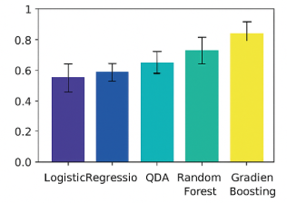
Figure 5: Model Comparison Chart (PyCaret)
PyCaret was utilized to compare various classifiers on the dataset transformed with PCA. Three algorithms, which were chosen to be analyzed specifically, namely Logistic Regression (LR), K-Nearest Neighbors (KNN), and Quadratic Discriminant Analysis (QDA), were all tuned and analyzed. The tuning of all the three models resulted in performance improvement. Confusion matrices showed high discrimination of the classes, although the highest number of correctly classified particular samples was always with KNN [11]. According to the classification reports, KNN had the highest F1-score, LR and QDA, respectively.
5.4 Best Model Selection
KNN was the most successful among the compared models which can be explained by the fact that the algorithm is the best in terms of its F1-score and balanced precision-recall characteristics properties across classes. The nonlinear modeling boundaries that KNN utilizes gave it an opportunity to take advantage of the clustering nature of the PCA-transformed wine data. Its usefulness with the dataset was further confirmed by its better performance following tuning (optimal k selection) [11].
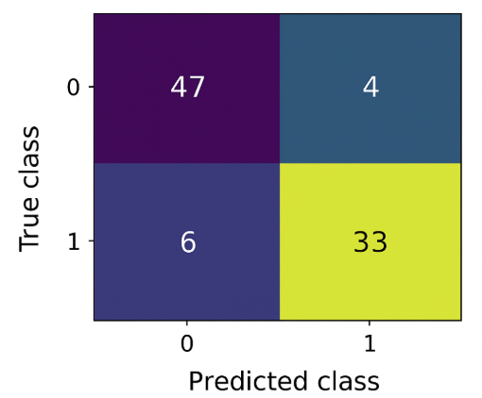-
Figure 6: Confusion Matrix (Best Model)
5.5 Performance Discussion
The variations between the models in terms of their performance are expected. On regions that were linearly separable, LR showed good classification though it had poor classification in overlapping regions between classes. QDA, which assumes covariance structures that are specific to individual classes, was fairly accurate but vulnerable to the distribution of classes. KNN was successful due to the fact that PCA retained spatial locality therefore distance-based learning to classify the samples successfully [11]. The results underline that dimensionality reduction does not only make the interpretation process easier but also increases the performance of the machine learning during the process of noise and multicollinearity reduction.
6. Explaining Models with Shap
6.1 Need for Model Transparency
With the growing role of machine learning models in decision making processes that relate to quality, it is important to understand why a model has made a prediction. Interpretability tools assist engineers in determining what features (or key components) contribute to quality classification and guarantee that there is confidence in automated classification systems. SHAP (Shapley Additive Explanations) is a simple and mathematically based system to measure the contribution of every feature to a prediction [12].
6.2 SHAP Theory Overview
SHAP relies on the cooperative game theory in which each feature serves as a player using its contribution to the final prediction [12]. The Shapley value is used to measure the relative marginal contributing of each feature to the overall combination of features. This allows equitability and uniformity in assigning significance. SHAP describes both global model behavior (what components have the greatest overall influence) and local behavior (why a particular sample is given a particular prediction).
6.3 SHAP Application in PyCaret
The most successful model was applied to SHAP (KNN or the next best supported model in the interpretability module of PyCaret) [10]. PyCaret has duplicate internally approximate or surrogate models to interpret non-tree classifiers since the exact algorithms of SHAP are optimized to use tree-based models. SHAP analysis was applied using the PCA-transformed features (PC1 6 ). The obtained summary plots and force plots permitted visualizing the comparative contributions of each component to the results of prediction.
6.4 SHAP Summary Plot Interpretation
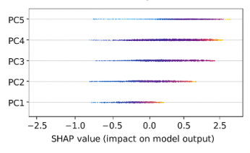
Figure 7: SHAP Summary Plot
SHAP summary plot ranked the principal components in terms of importance. PC1 always had the highest influence, PC2 had the second and PC3 the third influence. This rank coincided with the ratios of explained variances of PCA. The color distribution on the SHAP summary showed as higher values of PC1 generally drove the predictions towards certain classes of wine whereas a low value pushed it towards other classes. Such distribution patterns showed that there were nonlinear interactions between the major components and favored the dominant performance of KNN.
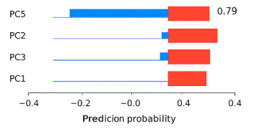
Figure 8: SHAP Force Plot
6.5 Correlation with PCA Findings
The interpretations of SHAP were in agreement with PCA. The variables that had the best explained variance were the ones that had most overall effect on the decisions of the model. The dependency of PC1 on flavonoids and intensity of colors was used as an example; PC1 had a high SHAP importance. According to this synergy, it can be seen that PCA does not only increase the performance of classification but also makes the process more explainable because it provides interpretable orthogonal features that can be analyzed better by SHAP [12].
7. Critical Discussion
7.1 Strengths of the Proposed Approach
The combination of PCA with supervised machine learning offered an effective and organized framework of data analysis in terms of quality. PCA was able to achieve a significant reduction of the dimensionality and retain more than 90 percent of the original information, which made it easier to visualize the data, boost the amount of computational power, and increase its interpretability. PCA and PyCaret made it faster and effortless to experiment with because it was reproducible and flexible in model comparison [4]. High predictive accuracy was obtained using the tuned KNN model in the PCA-transformed space, at which distance-based classification proved useful.
7.2 Limitations
Even though the results were good, a number of limitations were found. To begin with, PCA is linear in nature and cannot reveal nonlinear association in the data. Although PCA projections on low dimensions are helpful in visualization, in some cases, there can be overlaps between classes and this reduces the separability [4]. Second, KNN does not scale well when the data is noisy, or scales poorly with non-optimal data, but standardization helped to eliminate this problem [11]. Third, SHAP has no direct integration with non-tree-based models, necessitating surrogate models in order to interpret them [12]. Finally, the Wine data is not very large or misbehaved, which is not necessarily true to the complexity of real-world industry [6].
7.3 Practical Implications
The paper shows how PCA can apply to determine the real quality drivers by presenting the impactful chemical constituents. Similar pipelines driven by PCA can be used in industries like food and beverage, pharmaceuticals and manufacturing, to identify quality deviation, save on time of inspection and develop predictive quality control mechanisms [3]. The insight into the key aspects that are truly important allows organizations to track the essential quality attributes (CQAs) better and invest in managing the most influential elements.
7.4 Potential Industrial Application
PCA may be added to Statistical Process Control (SPC) dashboards in an industrial quality monitoring environment to monitor multivariate changes. The products that have unusual combinations of features that indicate quality defects could then be automatically flagged by machine learning classifiers [5]. This type of system assists in making real-time decisions, and may supplement the conventional control charts with more sophisticated and data-driven information on multivariate quality behavior.
7.5 Comparison to Traditional Quality Methods
Simple threshold-based rules or univariate control charts are the traditional approaches and would not be useful in situations where multicollinearity occurs or the data involved are high-dimensional. PCA helps to solve these problems by orthogonalizing feature space, eliminating redundancy, and improving pattern recognition. Machine learning models also go beyond the traditional quality tools by allowing predictive analytics as opposed to the descriptive surveillance. Collectively, PCA and ML offer a more complete contemporary alternative to the existing traditional process capability analysis and quality inspection models [2].
8.Conclusion and Future Work
8.1 Summary of Findings
This paper used PCA and three supervised learning algorithms which included LR, KNN, and QDA on the Wine data to determine the effectiveness of each learned algorithm in quality classification. PCA was able to compress the initial dataset of 13 dimensions to 6 factors that retained more than 90 percent of the variation. The outcomes of machine learning had resulted in the fact that the tuned KNN model had the best classification rates in the PCA-transformed space. SHAP analysis offered further interpretability with top component-principal components ranked in order of their influence on model predictions indicating consistency between PCA variance and model importance.
8.2 Achievement of Research Objectives
Every research aim was attained successfully. The PCA was properly applied, machine learning methods were tested and compared, and the model explainability was also included with the usage of SHAP. The article has shown the benefit of using dimensionality reduction with supervised learning to perform quality assessment tasks [12].
8.3 Lessons Learned
Among them, one can name the fact that dimensionality reduction does not only simplify the data but can also increase the level of classification performance by removing noise and multicollinearity. The other learning point is the importance of the interpretability of the model; it is valuable to know how the features contribute to the predictions to confirm the credibility of automated quality systems.
8.4 Recommendations
To implement in practice, companies ought to incorporate multivariate quality control systems that are based on the PCA-driven strategies, particularly where quality measures are correlated. Also, the use of several ML models formulated with the help of automated systems such as PyCaret will considerably save time on experimentation. Modellers should always be accompanied with interpretability techniques like SHAP in order to guarantee transparency [3].
8.5 Future Research Directions
Further research might involve (1) use of nonlinear dimensionality reduction algorithms like Kernel PCA or t-SNE to capture relationships with a complex data, (2) experimenting with ensemble models like Gradient Boosting or Random Forests to predict more accurately, (3) using PCA-based monitoring with internet-based SPC systems and (4) increasing the size of the dataset to reflect actual industrial quality measurements [4]. Another promising direction is the investigations of the deep learning methods of multivariate quality data.
References
[1] | K. S. a. V. R. K. Krishnamoorthi, integrating statistical and management methods of quality, cRc press, 2018.
[2] | S. J. Morrison, "Statistical engineering: the key to quality," Engineering Science and Education Journal, vol. 6(3), pp. 123-127, 1997.
[3] | E. Kurilovas, " "On data-driven decision-making for quality education."," Computers in Human Behavior, vol. 105774, p. 107, 2020.
[4] | H. a. L. J. W. Abdi, ""Principal component analysis."," Wiley interdisciplinary reviews: computational statistics, Vols. 2,4, pp. 433-459, 2010.
[5] | M. Lease, " "On quality control and machine learning in crowdsourcing."," Human Computation, vol. 11.11, p. 1085, 2011.
[6] | R. X. A. J. M. a. V. F. de Azambuja, ""X-wines: A wine dataset for recommender systems and machine learning."," Big Data and Cognitive Computing, vol. 7.1, p. 20, 2023.
[7] | A. a. R. S. K. Zonnenshain, ""Quality 4.0—the challenging future of quality engineering."," Quality Engineering, vol. 32.4, pp. 614-626., 2020.
[8] | S. K. E. a. P. G. Wold, ""Principal component analysis."," Chemometrics and intelligent laboratory systems, Vols. 2.1-3, pp. 37-52., 1997.
[9] | J. a. S. S. Bai, ""Estimating high dimensional covariance matrices and its applications."," 2011.
[10] | G. Tolios, ""Simplifying Machine Learning with PyCaret."," 2023.
[11] | K. S. e. a. Kim, ""Comparison of k-nearest neighbor, quadratic discriminant and linear discriminant analysis in classification of electromyogram signals based on the wrist-motion directions."," Current applied physics, vol. 11.3, pp. 740-745., 2011.
[12] | S. S.-H. H. a. J.-S. J. Mangalathu, ""Failure mode and effects analysis of RC members based on machine-learning-based SHapley Additive exPlanations (SHAP) approach."," Engineering Structures, vol. 219, p. 110927, 2019.

